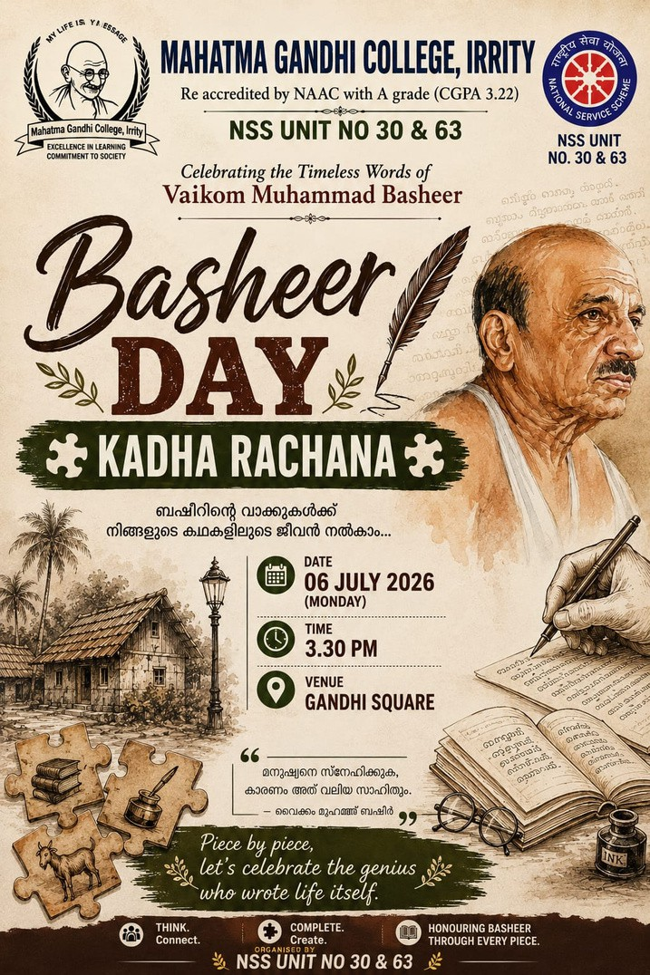
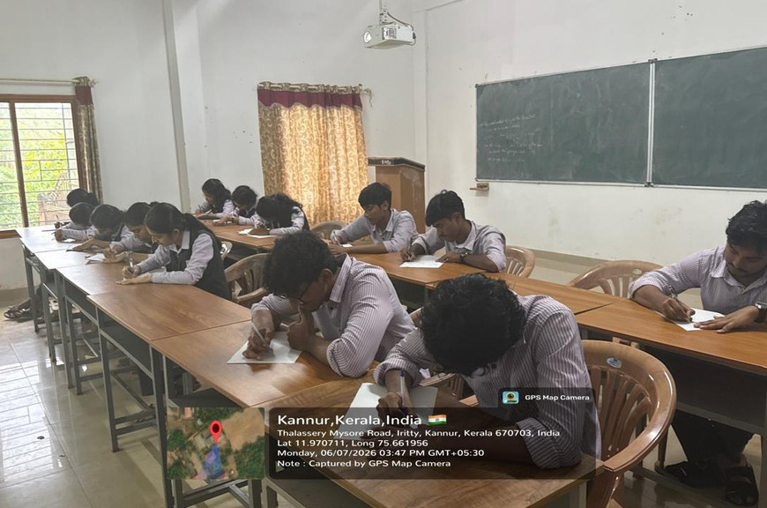
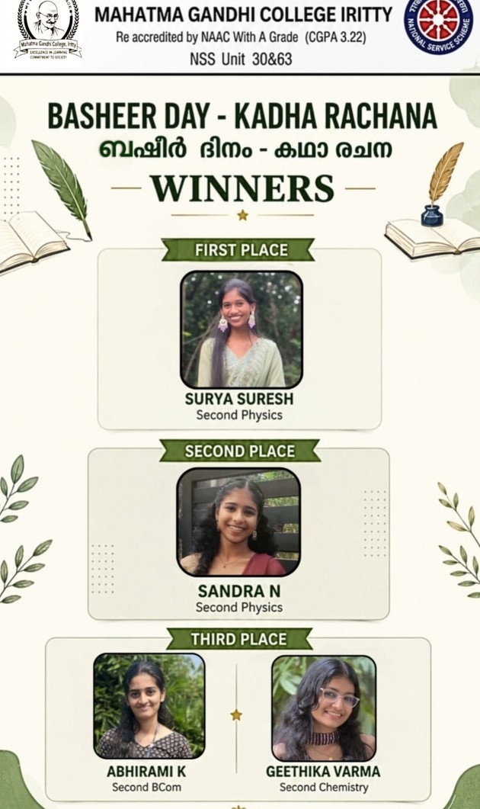
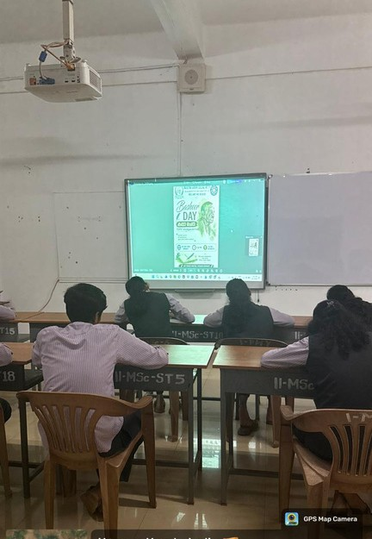

NSS Programme Report

Basheer Day – Story Writing Competition

College: Mahatma Gandhi College, Iritty NSS Units: 30 & 63
Programme: Basheer Day – കഥാ രചന (Story Writing Competition)
Date: 06 July 2026
Time: 3:30 PM
Venue: 2nd MSc Mathematics Classroom

The NSS Units 30 and 63 of Mahatma Gandhi College, Iritty organized a Basheer Day Story Writing Competition on 06 July 2026 to commemorate the birth anniversary of the legendary Malayalam writer Vaikom Muhammad Basheer. The programme aimed to inspire students to develop their creative writing skills while appreciating Basheer's unique literary style and contribution to Malayalam literature.

Students from various departments enthusiastically participated in the competition. They showcased their imagination, creativity, and storytelling abilities through original stories reflecting social values, human emotions, and everyday life, in the spirit of Basheer's writings

The competition was conducted smoothly under the guidance of the NSS Programme Officers. After careful evaluation, the following students were declared winners:

Winners

First Prize: Surya Suresh – 2nd Year Physics

- Second Prize: Sandra N – 2nd Year Physics
- Third Prize: Abhirami K – 2nd Year B.Com

Third Prize: Geethika Varma – 2nd Year Chemistry

The programme concluded with the announcement of the winners and appreciation for all participants. The event successfully encouraged literary creativity among students and paid a meaningful tribute to the timeless legacy of Vaikom Muhammad Basheer.

