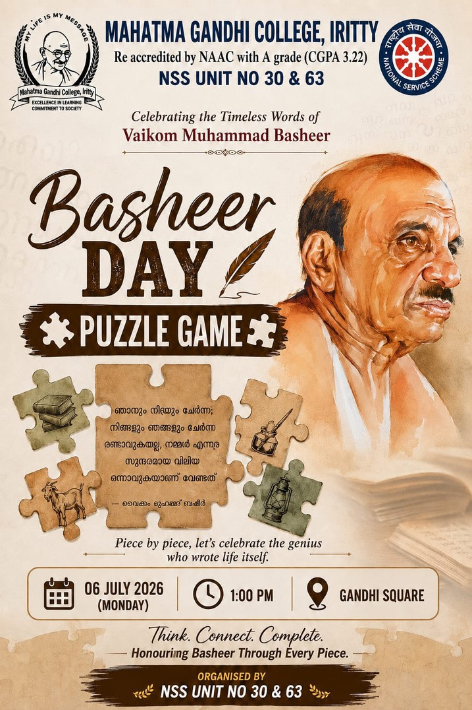
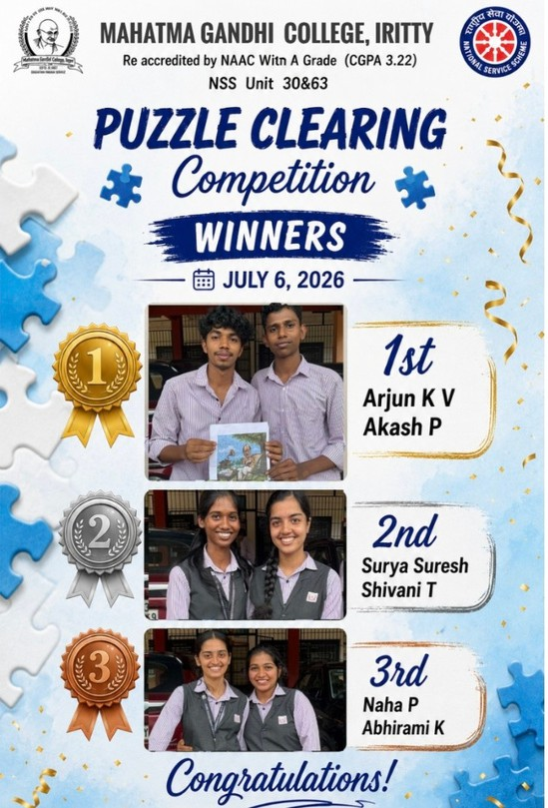
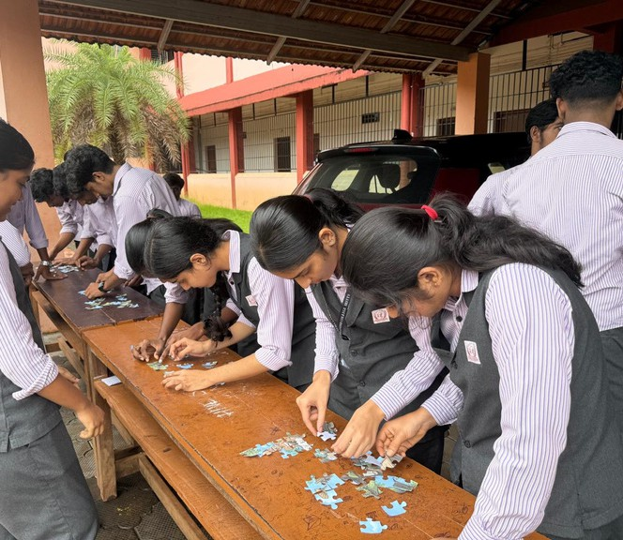
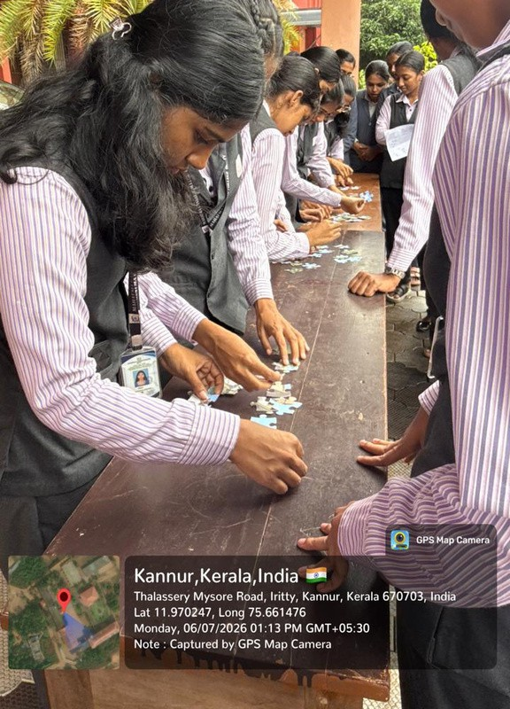

NSS Programme Report

Puzzle Clearing Competition
Programme: Puzzle Clearing Competition Organized by: NSS Units 30 & 63
College: Mahatma Gandhi College, Iritty Date: 06 July 2026
Venue: College Campus

Report
The NSS Units 30 and 63 of Mahatma Gandhi College, Iritty organized a Puzzle Clearing Competition on 06 July 2026 as part of the college's co-curricular activities. The programme aimed to improve students' problem-solving ability, logical thinking, teamwork, and time management skills.

Students from different departments enthusiastically participated in the event. Each team was provided with a jigsaw puzzle and challenged to complete it accurately within the allotted time. The participants displayed excellent coordination, concentration, and competitive spirit throughout the competition.

The programme was successfully conducted under the guidance of the NSS Programme Officers with the support of NSS volunteers. The event created an engaging and enjoyable learning experience for all participants and encouraged teamwork and healthy competition.

Winners

🥇 First Prize

Akash P (II B.Com) Arjun K. V(II B.Com)

🥈 Second Prize

Shivani T(II Physics) Surya Suresh(II Physics)

🥉 Third Prize

Naha P(II B.Com)
Abhirami K(II B.Com)

The program concluded with the distribution of prizes and appreciation for all the participants. The event was a great success and helped develop critical thinking, teamwork, and confidence among the students.

