National Service Scheme (NSS) Event Report
Topic: Statistics Day Celebration & Sudoku Competition
Organized by: NSS Unit No. 30 & 63, Mahatma Gandhi College, Iritty
Date: July 10, 2026
Time: 1:00 PM
Venue: 1 BSc Mathematics Classroom
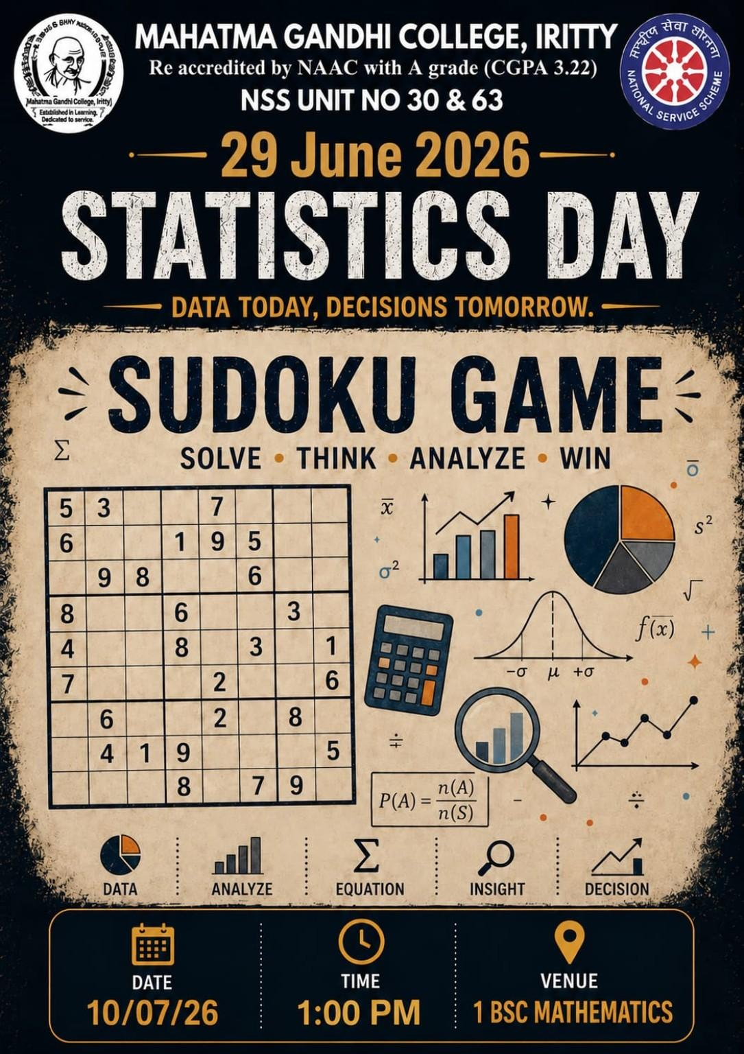

Introduction
In commemoration of National Statistics Day (originally June 29), a 'Sudoku Game' competition was organized for the students under the joint auspices of NSS Units 30 and 63 of Mahatma Gandhi College, Iritty. The event was centered around the theme 'Data Today, Decisions Tomorrow.' The primary objective of the program was to foster analytical skills, logical thinking, and problem-solving abilities among the students.

Event Highlights
The competition commenced promptly at 1:00 PM on Friday, July 10, 2026, at the First-Year B.Sc. Mathematics classroom. A significant number of students from various departments across the college enthusiastically participated in the event. The participants were challenged with a well-crafted Sudoku puzzle designed to test their cognitive and speed-solving capabilities under a set time limit. The atmosphere was highly engaging, with students demonstrating great focus and spirit.

Conclusion
The event proved to be highly beneficial in stimulating intellectual thinking and providing a productive mental exercise for the students. Thanks to the meticulous planning and coordination by the NSS volunteers and program officers, the event was concluded successfully. The NSS units extend their appreciation and congratulations to all the participants and winners.

Event Photographs
