**MAHATMA GANDHI COLLEGE , IRITTY**

**Report of Activities of Bhoomithra Sena Club: 2023-2024**

College Bhoomithrasena Club has an active role in keeping the campus green and environment ecofriendly. Bhoomithrasena club undertook the following programmes during this year.

1. ***World Environment Day Celebration***

The Bhoomithra Sena Club of Mahatma Gandhi College,Iritty started “GURUVANAM”,

College Principal Dr Swarupa R inaugurated the programme by planting a sapling. Besides saplings were palnted by teaching and administrative staffs.



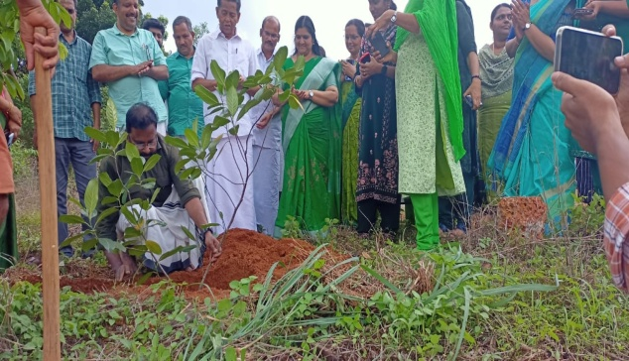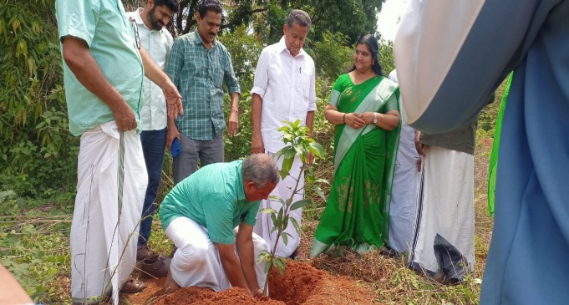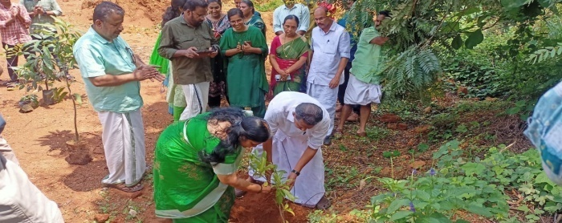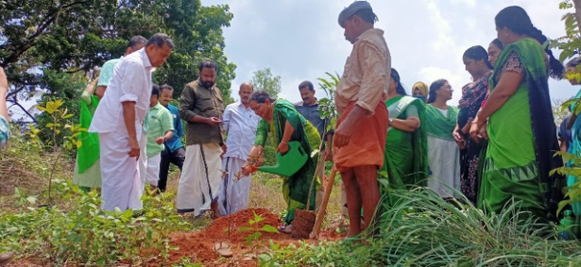

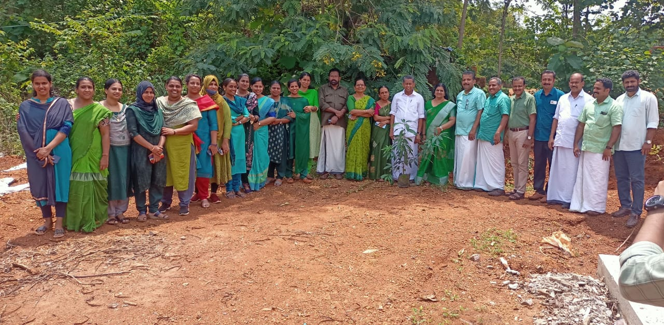

2. **Inter Collegiate Green Quiz**

The Bhoomithra Sena Club of Mahatma Gandhi College,in association with Green Leaf ,Iritty organized Green Quiz on 21st July 2023 to commemorate **‘Chandra Dinam’**. 23 teams from various colleges affiliated to Kannur University participated. Dr Swarupa R, Principal inaugurated the programme. Sri T A Justin , Chairman Green Leaf presided over the function. Mrs Priyanka P( Co-ordinator BMC)and Mr Rejeesh E spoke on the occasion. The team consists of Athulya P P and Dawn Joe Abraham (Mary Matha Colllege, Alakkodu) , Nandana M , Geethika U K (Govt Brennen College, Thalassery) and Anand Sreedharan, Aswanth (M G College, Iritty) won first ,second and third place respectively. All teams were awarded with participation certificates in the award ceremony which was attended by officials from Green Leaf and the Head of the Departments of Mahatma Gandhi College. The programme was widely appreciated as informative and entertaining with the focus on spreading proper ecological awareness among students

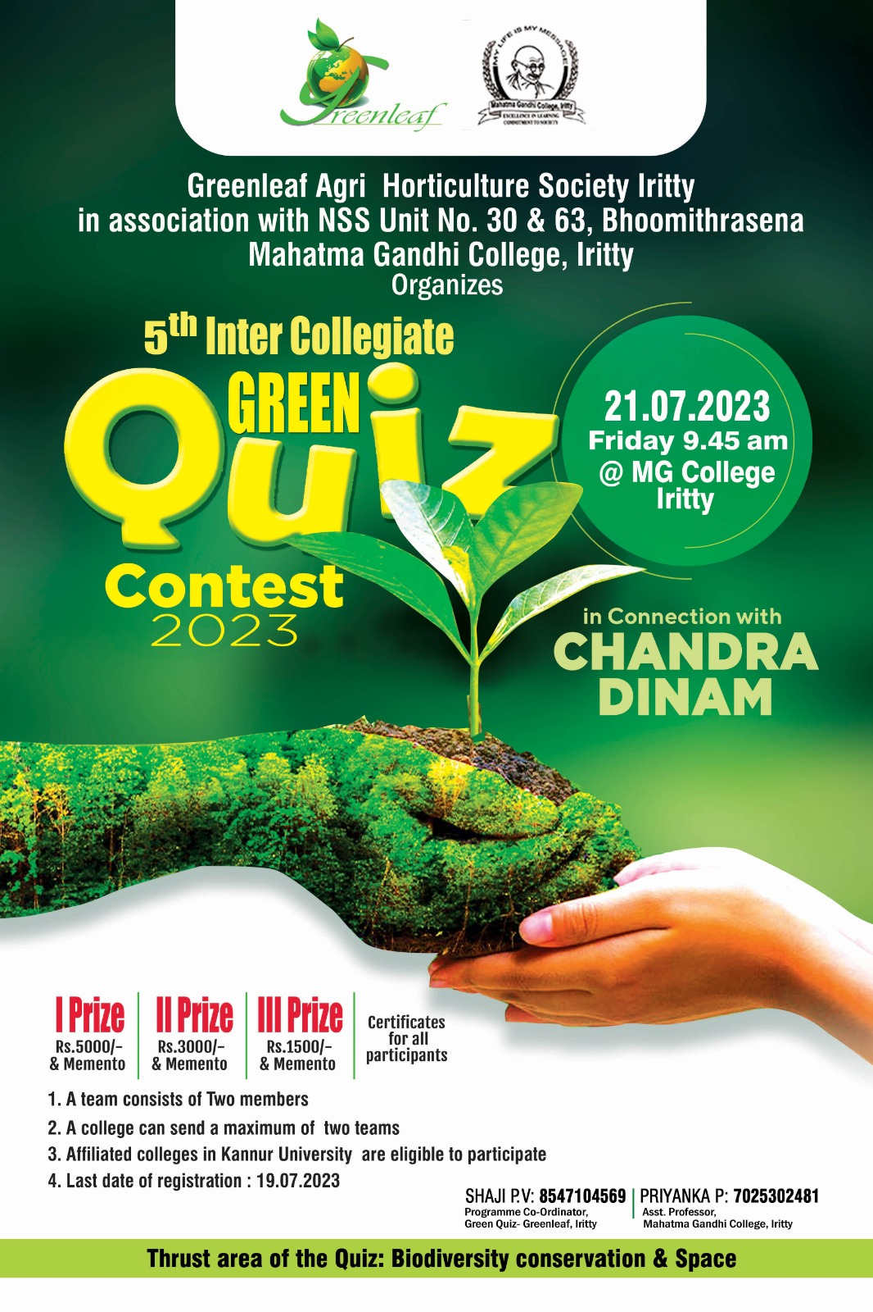

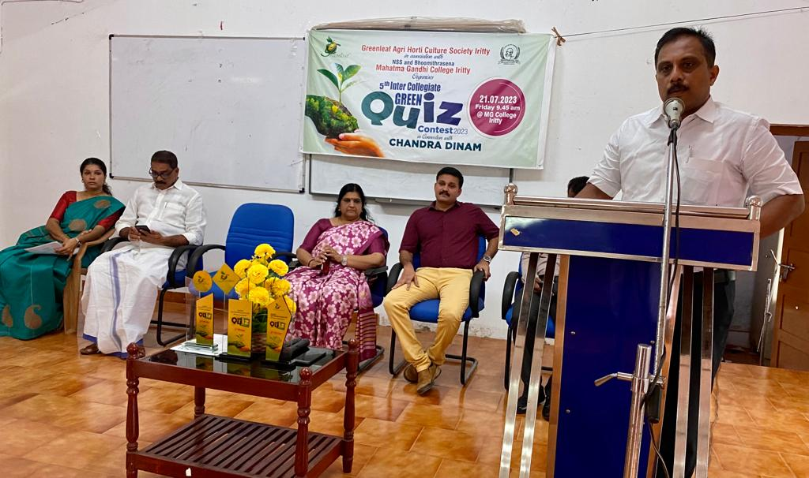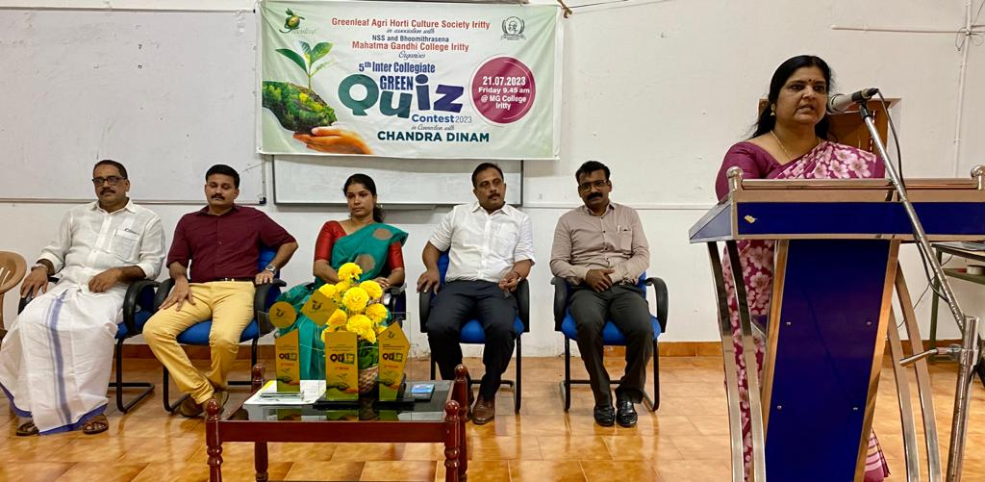

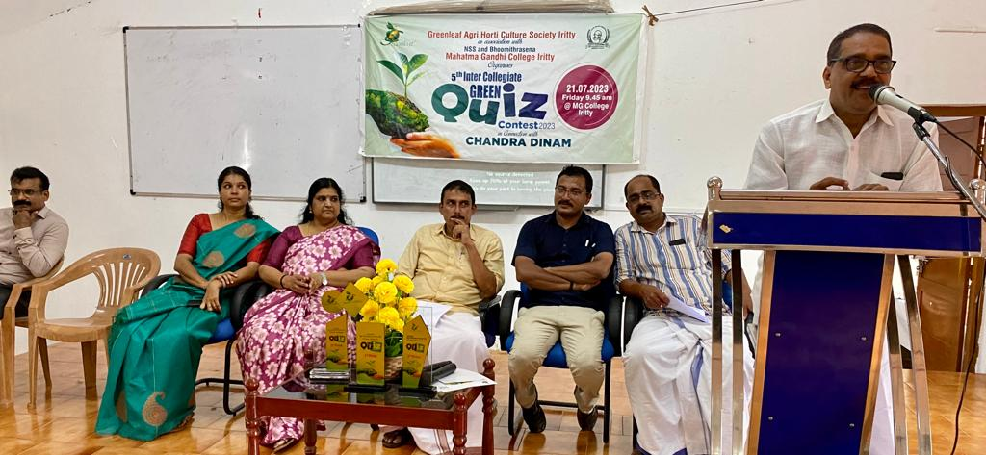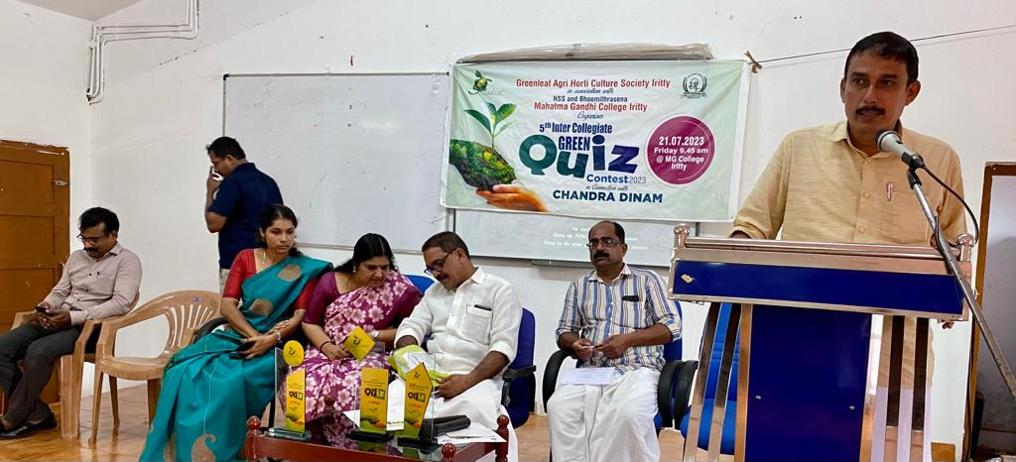

Link: കണ്ണൂര്‍ സര്‍വകലാശാലതല ഇന്റര്‍കോളജിയറ്റ് ഗ്രീന്‍ ക്വിസ് മത്സരം

<https://fb.watch/lW5Wp8gCc5/>

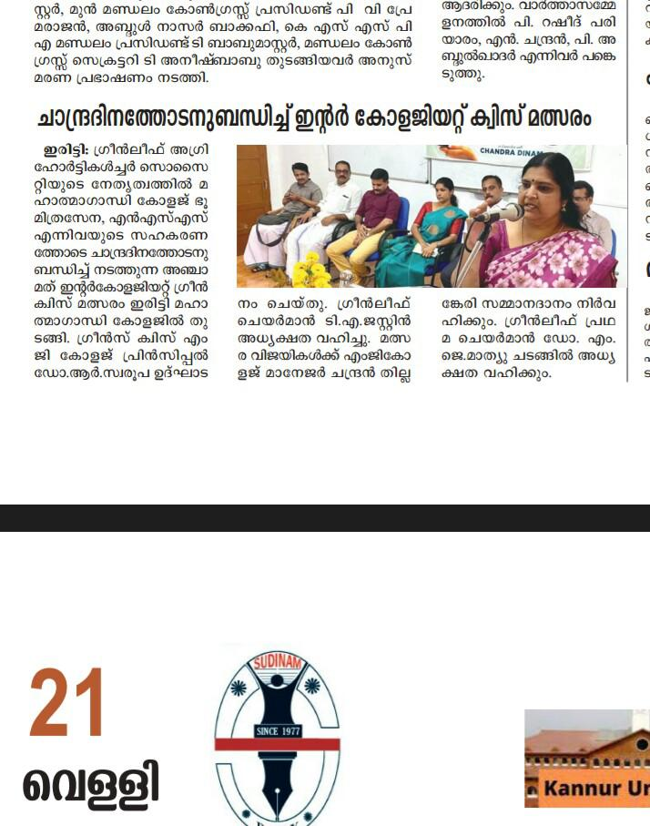

.

1. ***Speech Competition***

As part of Gandhi Jayanthi two week long programmes 2023 , college bhoomithrasena club in association with Mahatma Gandhi study circle oragized speech competition on 04.10.2023. 9 student representatives actively participated in the programme. Abhishek K (II BSC Computer Science) and Jwala M Jose bagged I and II places respectievely.

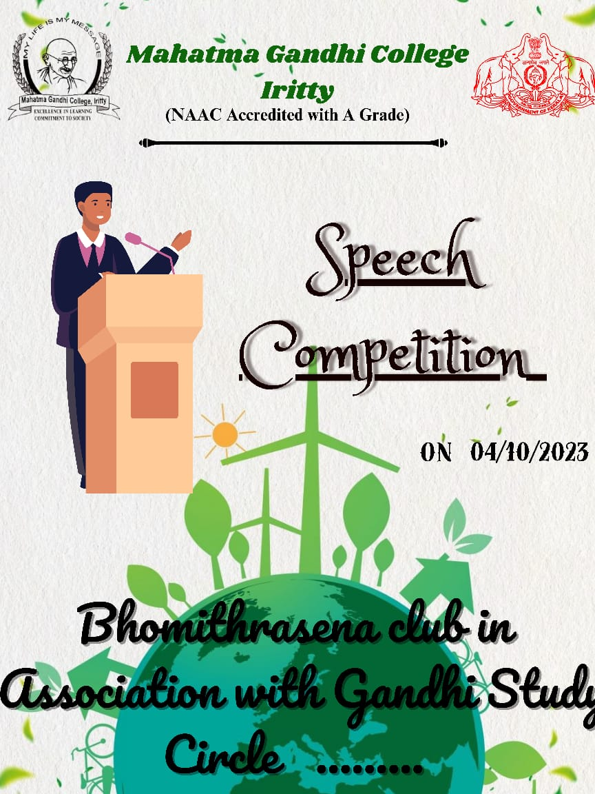

1. ***Green Audit***

The Bhoomithrasena Club organized a green audit within the campus premises, meticulously cataloging over 50 plants. Dr. Dileep, an esteemed environmentalist, spearheaded the audit process. His expertise and guidance ensured thorough documentation and assessment of the campus vegetation. This initiative underscores the club's commitment to environmental stewardship and promoting biodiversity awareness within the college community.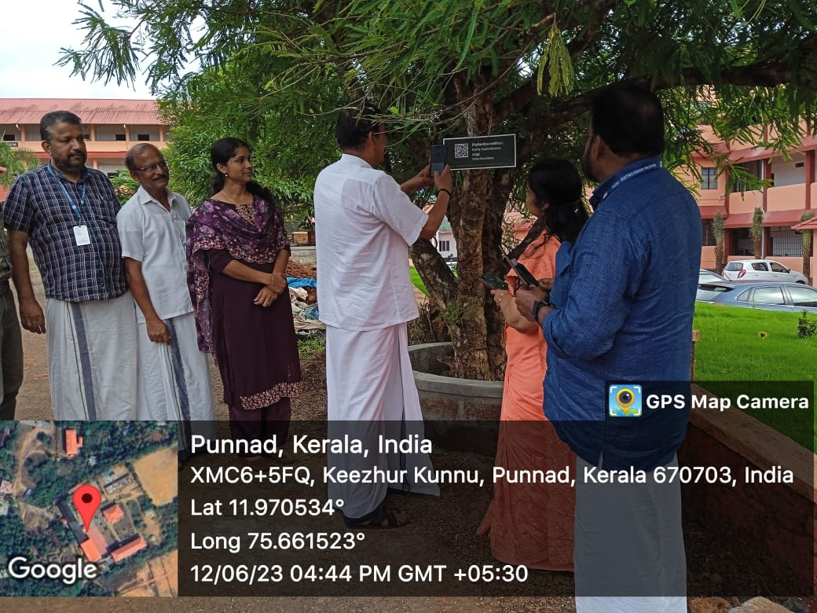

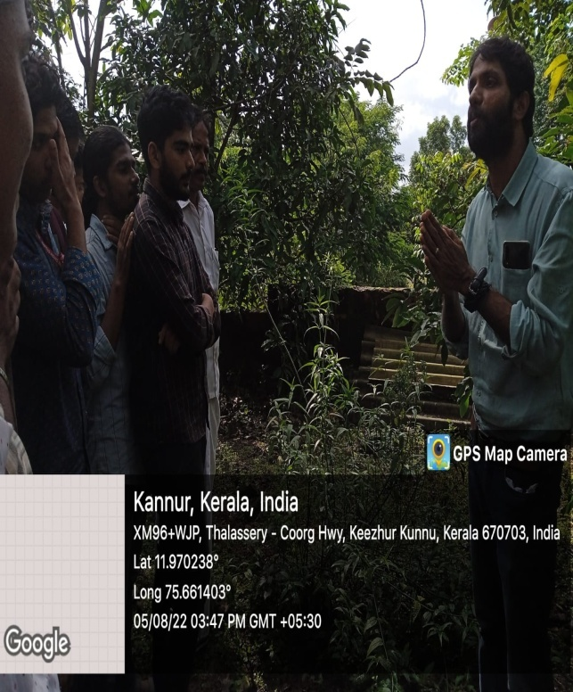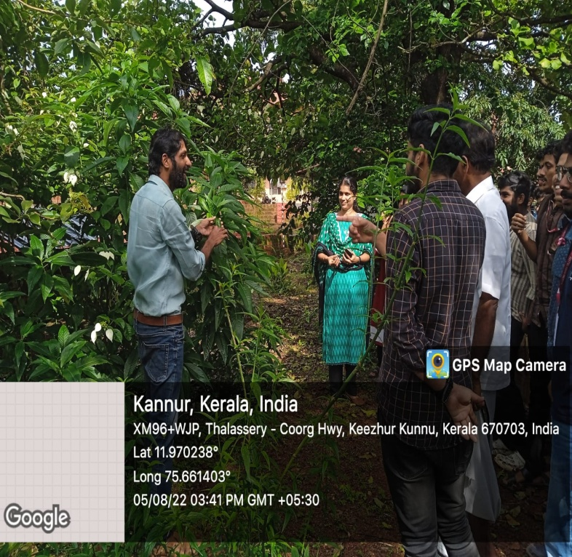

1. ***Green Awarness initiatives***

The Bhoomithrasena Club initiated a campaign to affix awareness stickers addressing the responsible use of water and electricity onto walls. These stickers aim to educate and remind individuals about the importance of conserving these resources.



1. ***Wildlife Week Celebration***

As part of wildlife week celebration 2023, bhoomithrasena club in association with Kerala Forest department actively participate “Nagaravanam cleaning programme” at Sanjeevani Vanam, Valliad.

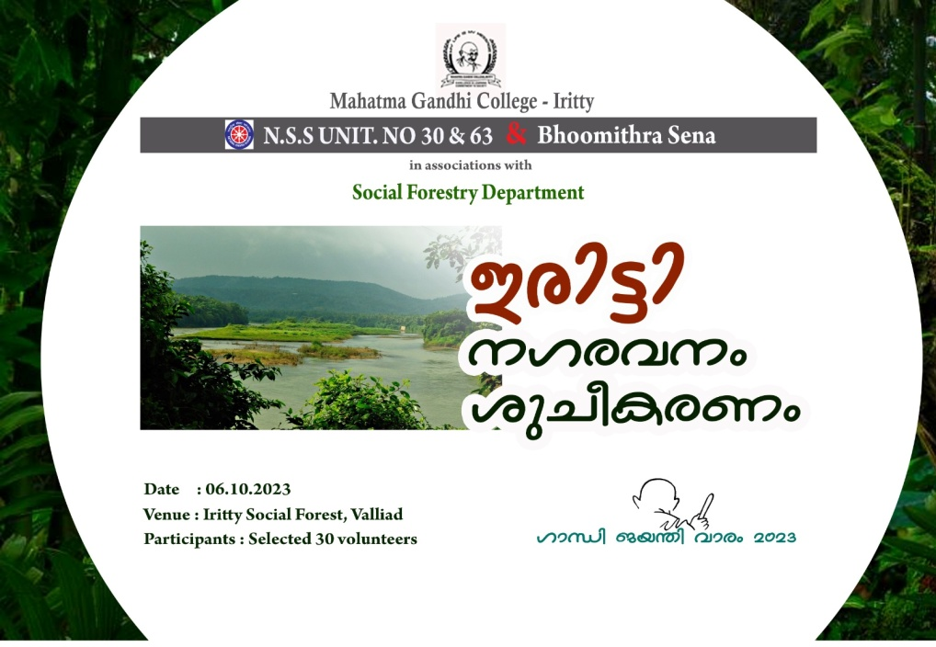

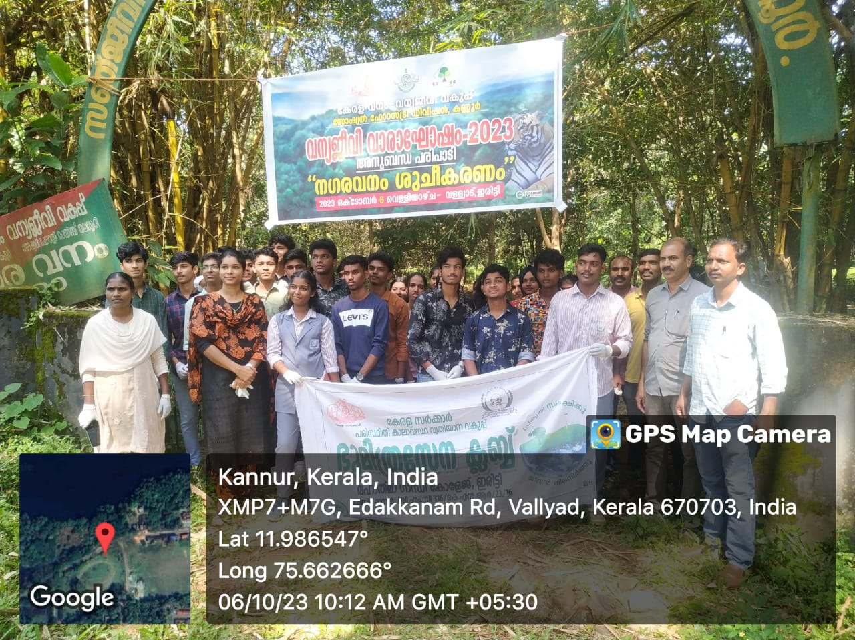

***Link :*** [***https://youtu.be/3EbxVQCidEg?si=9L0mM-Q2yyn2z3xr***](https://youtu.be/3EbxVQCidEg?si=9L0mM-Q2yyn2z3xr)

1. ***Vegetable Saplings Distribution***

The Bhoomithrasena Club distributed over 400 vegetable saplings to the teaching and non-teaching staff as well as students of our college. The function was inaugurated by Municipal Councillor Sri Sameer Punnad. This initiative aims to encourage gardening and promote sustainable practices within our college community.

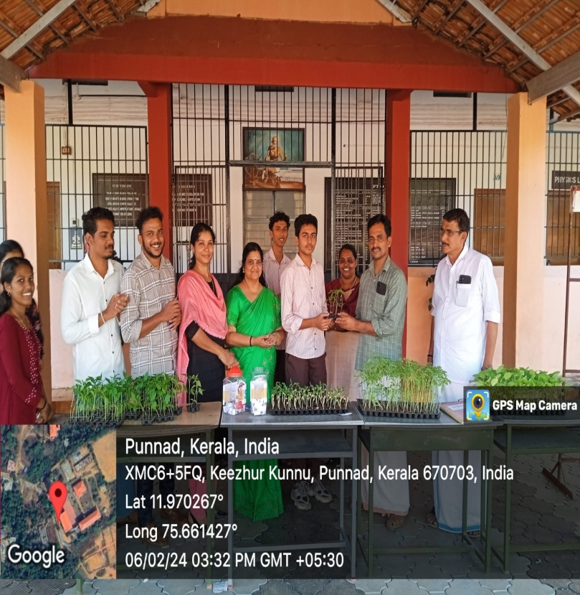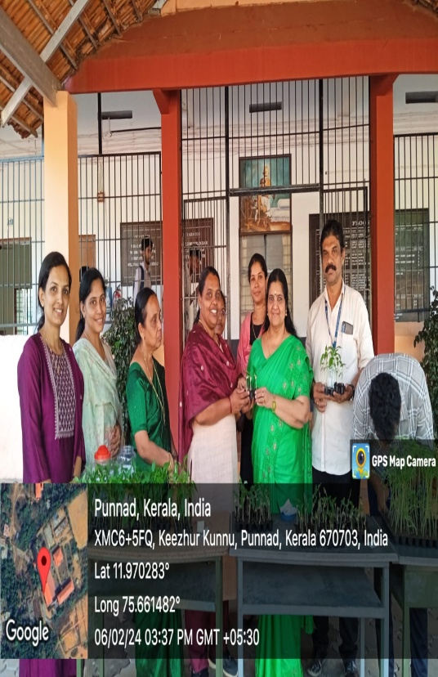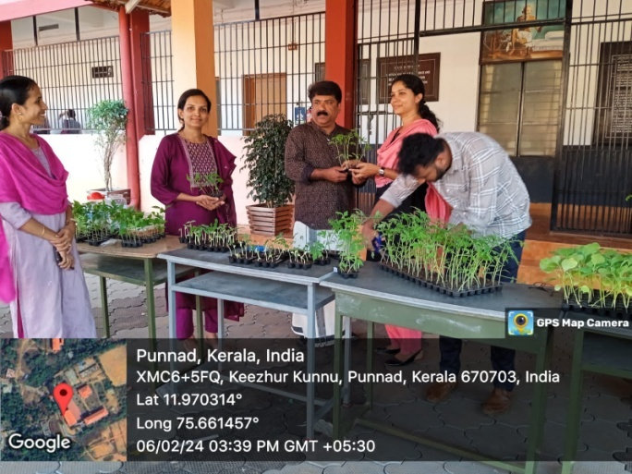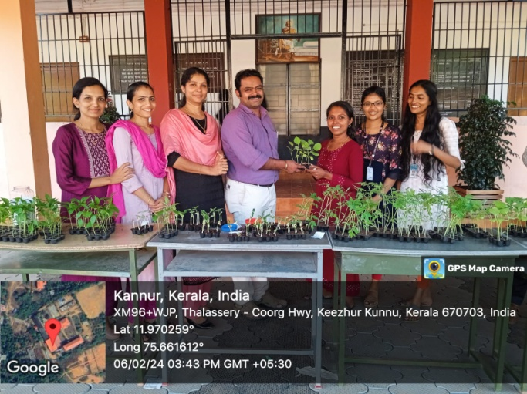

1. ***Grow Bag and Vegetable sapling distribution***

The Bhoomithrasena Club generously distributed over 20 grow bags and vegetable saplings to the Keezhurkunnu Anganavadi, aiming to encourage the consumption of pesticide-free vegetables among children. The program was inaugurated by the College Principal, who planted the first sapling. Municipal Councillor Smt. Sindhu N presided over the session. Both teaching and non-teaching staff, along with BMC volunteers, enthusiastically participated in the program, demonstrating their commitment to the cause.

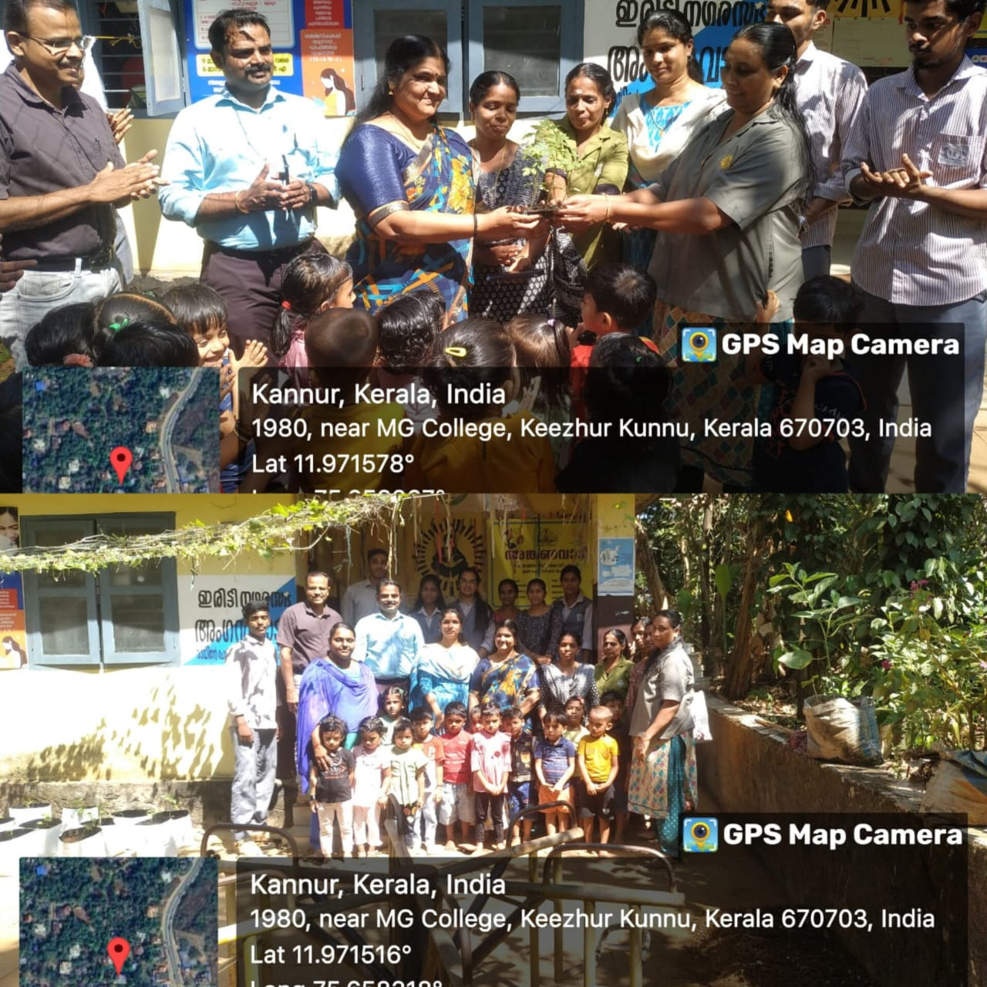

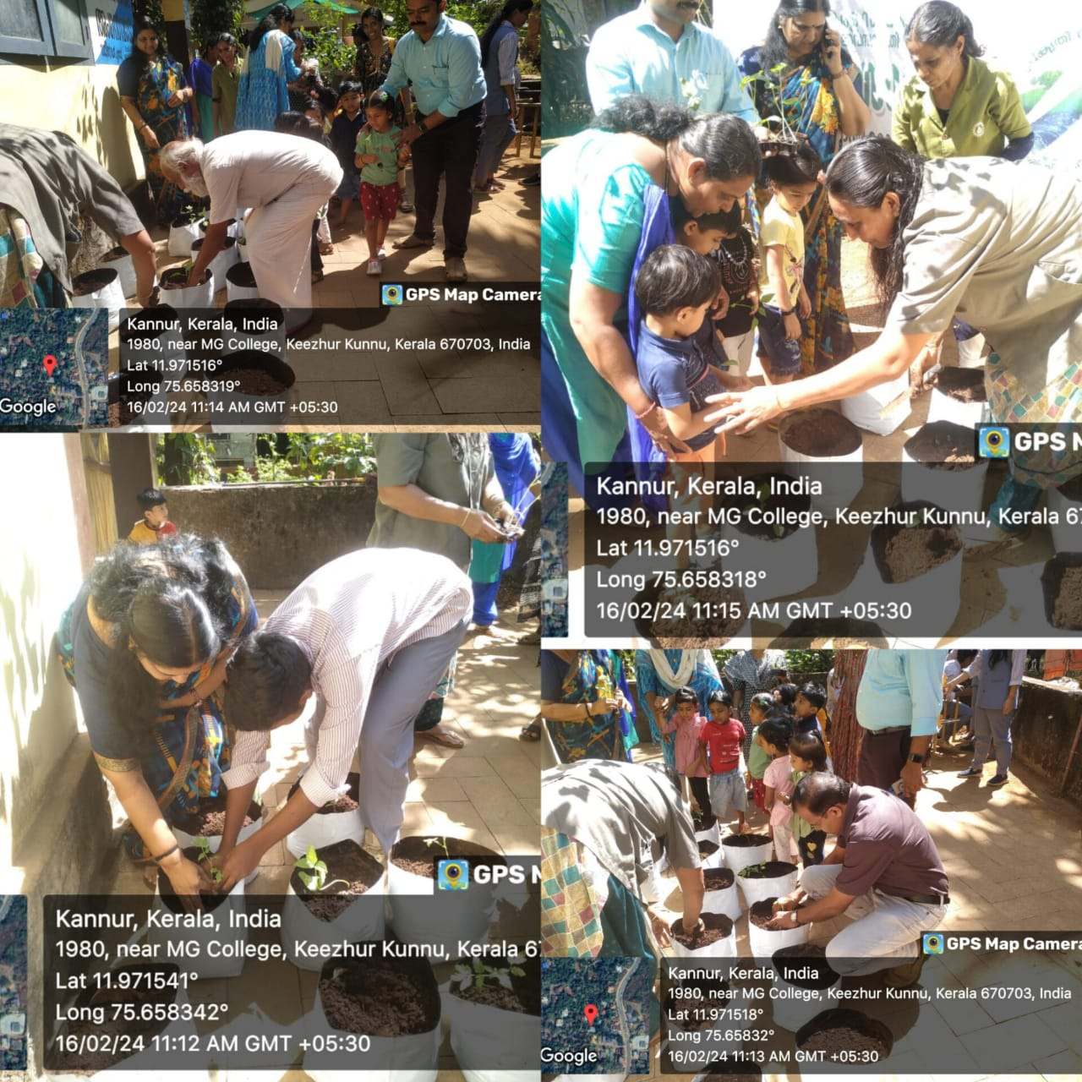

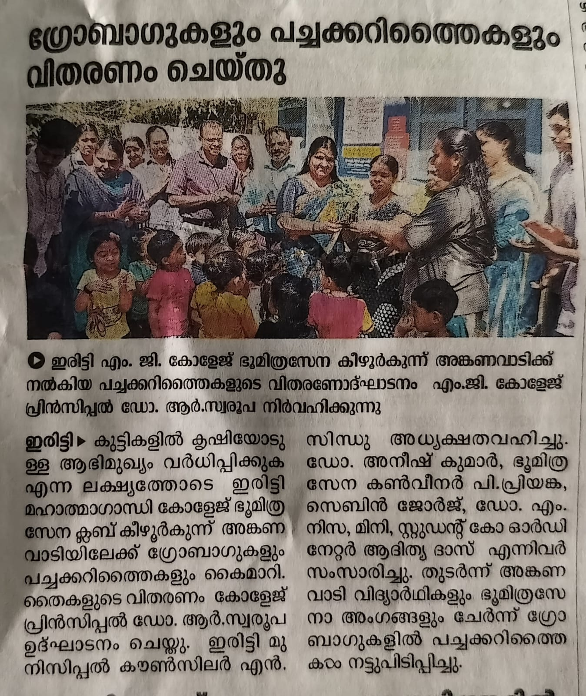

[**https://www.facebook.com/share/v/puSizJRnQZ24YWPs/?mibextid=qi2Omg**](https://www.facebook.com/share/v/puSizJRnQZ24YWPs/?mibextid=qi2Omg)

1. ***Cleaning Programme***(11.03.2024)

Bhoomithrasena Club volunteers conducted a road cleaning drive along the highway, demonstrating their commitment to environmental cleanliness. Their efforts not only enhance the aesthetic appeal of the area but also contribute to maintaining a hygienic and safe environment for commuters. The club's proactive approach in community service reflects their dedication to fostering a cleaner and healthier society.

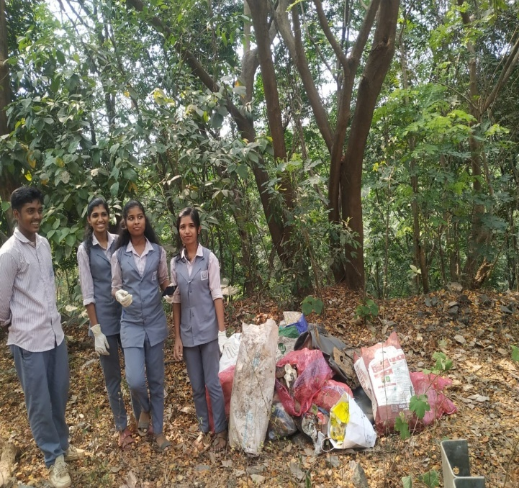 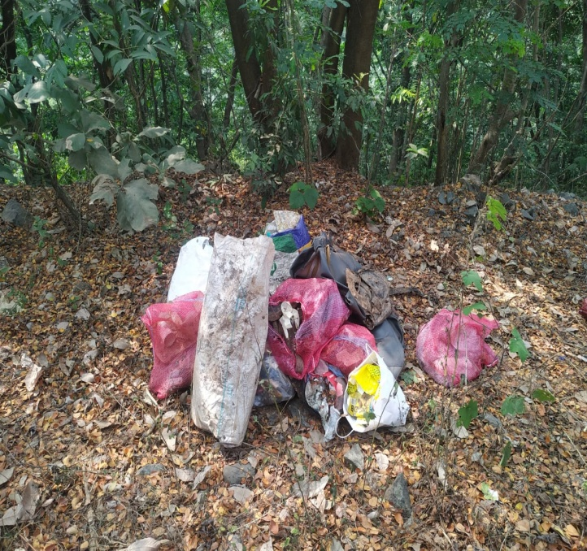

1. ***ECOALERT***

The Bhoomithrasena Club initiated the "ECOALERT" program, with the primary objective of raising environmental consciousness and safeguarding green spaces. An essential component of this endeavor involved the installation of a prominent name board along the National Highway, serving as a visible reminder of the initiative's mission. The program received official inauguration by Municipal Chairperson Smt. Sreelatha, highlighting the community-wide support for environmental causes. College Principal Dr. Swarupa R delivered a keynote address, emphasizing the significance of preserving nature for future generations. Priyanka P, the BMC Convenor, played a pivotal role in coordinating the program's activities and ensuring its success. Dr. Nisa M, along with dedicated BMC volunteers and teachers, actively engaged in various aspects of the initiative, demonstrating their collective commitment to environmental stewardship. The participation of diverse stakeholders underscored the widespread acknowledgment of the importance of environmental conservation within the community. Through collaborative efforts and sustained action, the ECOALERT program aims to foster a culture of environmental responsibility and inspire positive change at both local and global levels.

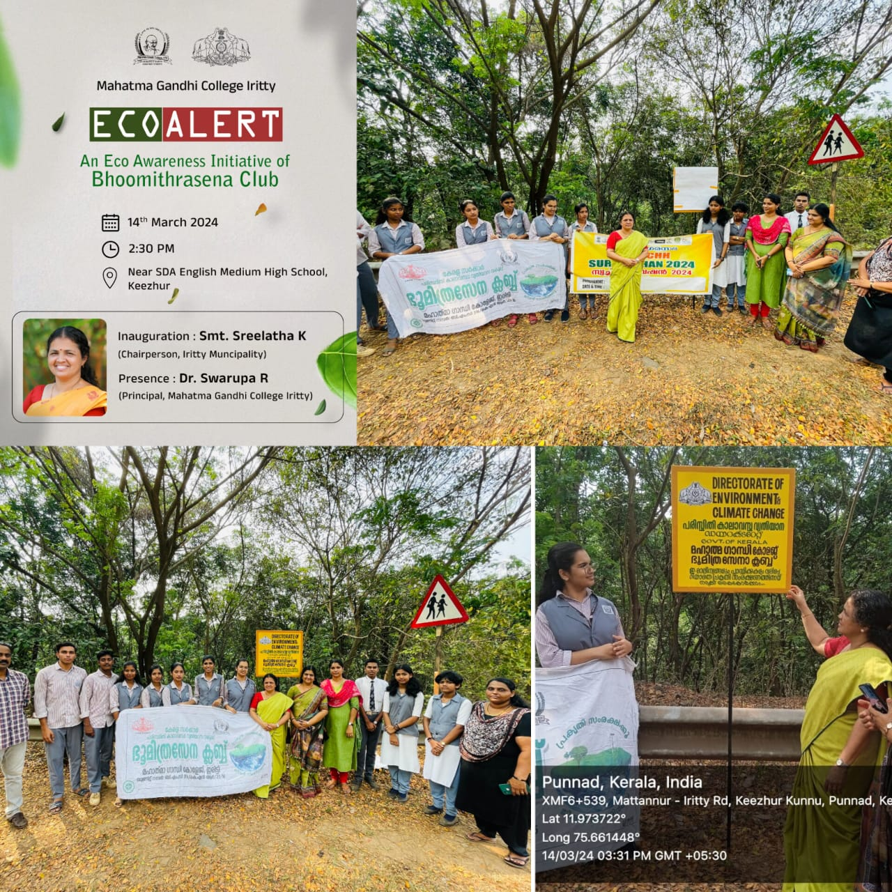

1. ***Paravakalkkoru Neerkudam(16.03.2024)***

Bhoomithrasena Club volunteers placed water pots near the campus premises in observance of Sparrow Day, aiming to provide essential hydration to birds. This initiative contributes to the conservation efforts for avian species and fosters a bird-friendly environment around the campus. The club's dedication to wildlife welfare is evident through such thoughtful gestures.

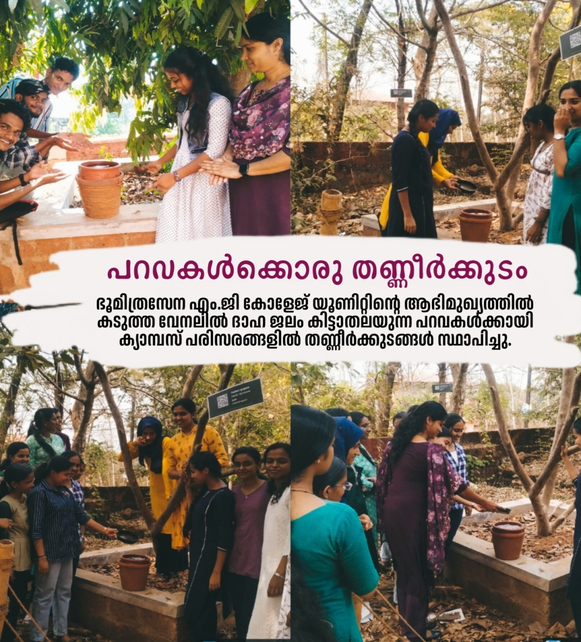

.

Priyanka P

Convenor-BMC