Research Methodology Workshop on the Topic: The Possibilities of Mathematical Research in Computer Science
on 30th August 2024
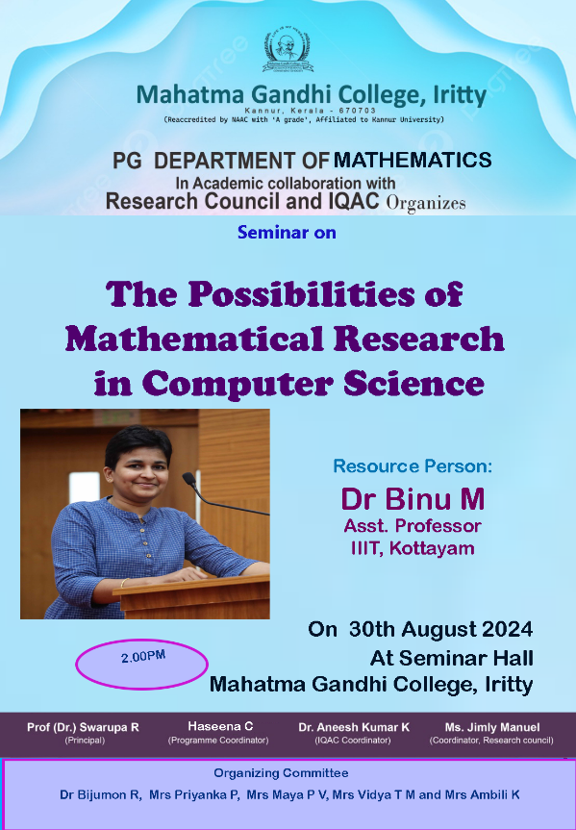
A seminar on “The Possibilities of Mathematical Research in Computer Science” was organized by the PG Department of Mathematics in academic collaboration with the Research Council of Mahatma Gandhi College, Iritty, and IQAC on 30th August 2024 at 2 PM. The event was attended by faculty members and students, primarily MSc students. The seminar was presided over by the Principal, Prof. (Dr.) Swarupa R.
The program began with a warm welcome address by Dr. Bijumon, HoD of the PG Department of Mathematics. Mrs. Haseena C., Coordinator of the program, introduced the resource person, Dr. Binu P., Assistant Professor at IIT Kottayam. Dr. Binu P. elaborated on how mathematical research in computer science drives advancements in algorithms, enabling efficient problem-solving across various industries. He highlighted its role in fostering innovations in fields such as cryptography, artificial intelligence, and data analysis by developing new theoretical frameworks and models. He also emphasized its impact on computational complexity, enhancing our understanding of the limits of computation.
The seminar concluded with a vote of thanks by Mrs. Jimly Manuel, Convener of the Research Council, who expressed gratitude to the resource person and participants for their valuable contributions to the session.


